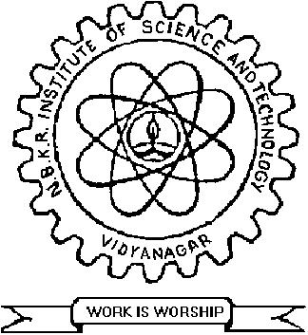 | N.B.K.R. INSTITUTE OF SCIENCE&TECHNOLOGY  (AUTONOMOUS)  Affiliated to JNTUA, Anantapuramu  All UG-Courses Accredited by NBA TIER- I :: Re-Accredited by NAAC (UGC) with 'A' Grade.  An ISO 9001: 2008 Certified Institution  Vidyanagar-524 413, SPSR Nellore Dt., A.P.  e-mail : ist@nbkrist.org, website : www.nbkrist.org, Phone : (08624) 228247

CHIEF PATRON :
Dr. I. Gopal Reddy
Chairman

PATRON:
Sri. N. Ram Kumar
Correspondent

PRESIDENT:
Dr. V. Vijaya Kumar Reddy
Director
CONVENOR :
Sri. N. Venkateswarlu
Assistant Professor

FACULTY CO-ORDINATOR:
Dr. D. Srinivas, HOD.
Dr. P.V.Subba Reddy
Sri. V. Balaji
Sri. V.V. Rambabu
Sri. P. Ranga Ramesh
Sri. M. Venkateswarlu
Dr. U.C.Bhaskara Reddy
Sri. Nambi Harish
Sri. M. Arun Kumar
Ms. S. Teja Reddy
Sri. K. Sundeep Kumar
Ms. SK. Reshma
Sri. S. Mohamed Hanif
Sri. K. Mahesh
Sri. P. Dileep Kumar
Ms. P. Janaki Lakshmi
Sri. G. Rahul Reddy

STUDENT CO-ORDINATORS :
K. Ravindra Reddy
SK. Waseem Akram
M. Sai Pavan Kumar
J. Chandrakanth
E. Bhavana
R. Sireesha

22/02/2017
PARIGRAH-2K17
A National Level TECHNICAL Symposium
(Organised by Department of Civil Engineering)
Email: parigrahnbkrist@gmail.com

To
The Principle / HOD,

Dear Sir /Madam,
Sub: Invitation for National Level Technical Symposium
PARIGRAH-2K17 from 20th to 21stMarch 2017- Reg.

At the outset let me thank you for your kind support in organizing the PARIGRAH events successfully every year. The response of students from all over India to participate in PARIGRAH events is overwhelming. We greatly appreciate the students from different states, who had enthusiastically sent their technical papers for presentation in earlier PARIGRAH event. We are glad to inform you that PARIGRAH-2K17 is scheduled from 20th – 21st march 2017.
In PARIGRAH-2K17, we organize Paper Presentations, Poster Presentations, Technical Quiz and Spot Events on 20th March 2017 and a one day workshop on “Self Compacting Concrete” on 21st march 2017. The winners and participants will be rewarded and certified.
I sincerely request you to encourage your students from Civil Engineering Department to send papers, posters and participate in workshop for PARIGRAH-2K17. I am here with enclosing a poster for display in your college notice board and brochures for your information.
With Warm Regards,

Dr. V.Vijaya Kumar Reddy
DIRECTOR

